Order Of Service

Singing: Psalm 84—CW page 96

Reading: Psalm 137

Opening Hymn: CW 260

Reading: James 5:1-6

Request Hymn: CW Supplement 754

Reading: Luke 20:9-18

Sermon Hymn: CW 363

Sermon Text: Song Of Solomon 2:3a

The Apple Tree

Prayer

The Apostles’ Creed, TLH page 12

Holy Communion

The Lord's Prayer

The Blessing

Closing Hymn: CW 245

* * * * * * * * * * *

Koinonia Hour

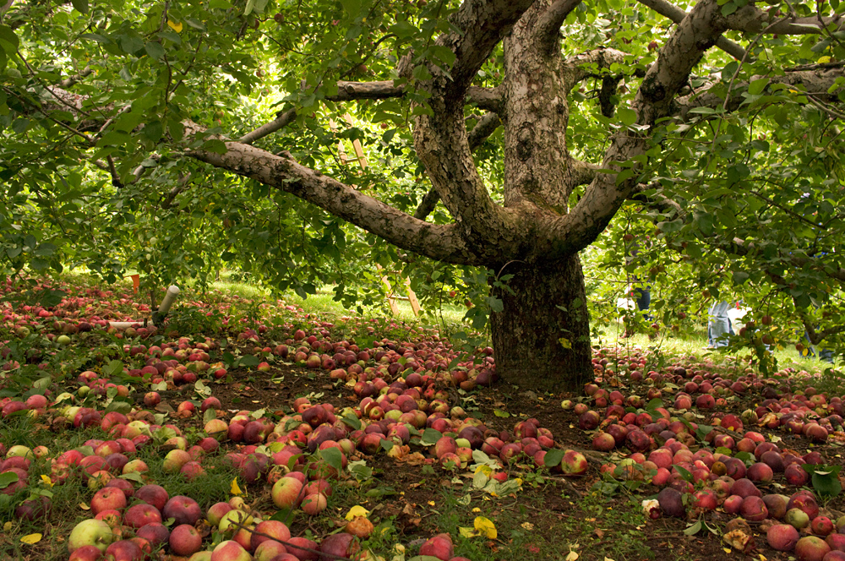

The Apple Tree

Water
Of
Life

1 November 2015

W A T E R O F L I F E

Independent Christian Church—Conservative Lutheran Doctrine

Worship Service: 9:30 a.m. Bible Study: 10:45 a.m.

Larry Cooper, Pastor E-Mail address:
111 N. Ridge Road lcooper@wateroflife.cc
Coon Valley, WI 54623 Web Site:
Phone: (608) 452-2105 www.wateroflife.cc

* * * * * * * * * * * * * * * * * * * * * * * * * * *

Sermon Text: Song Of Solomon 2:3a

The Apple Tree

* * * * * * * * * * * * * * * * * * * * * * * * * * *

3a: As the apple tree among the trees of the wood, so is my beloved among the sons.

An Overview

In the first two verses of chapter two of Song of Solomon, we hear the Bridegroom speaking. Now here in verse 3 we hear the Bride speaking. From verses 3-7 she speaks as if she is in close connection with her Bridegroom. But after that, beginning with verse 8, she speaks of her Bridegroom as being at some distance from her.

The Apple Tree

Jesus Christ is often compared to a tree in Scripture. A few examples:

Psalm 1:1-3

1 Blessed is The Man that walketh not in the counsel of the ungodly, nor standeth in the way of sinners, nor sitteth in the seat of the scornful.
2 But his delight is in the law of the LORD; and in his law doth he meditate day and night.
3 And he shall be like a tree planted by the rivers of water, that bringeth forth his fruit in his season; his leaf also shall not wither; and whatsoever he doeth shall prosper.

Psalm 80:15 And the vineyard which thy right hand hath planted, and The Branch that thou madest strong for thyself.

Isaiah 4:2 In that day shall The Branch of the LORD be beautiful and glorious, and the fruit of the earth shall be excellent and comely for them that are escaped of Israel.

Isaiah 11:1 And there shall come forth a rod out of the stem of Jesse, and a Branch shall grow out of his roots:

Here in Song of Solomon 2:3 the Bride compares her Bridegroom to The Apple Tree. Interestingly enough, there are some theologians—Luther among them, I believe—that claim that the tree of the knowledge of good and evil was an apple tree. And they write about Eve eating the apple. Is it possible that this is one of the verses they use to come to that conclusion?

